

**Employer Registration Form** Sole Trader / Self - Employed £ 45

Name of the Company*:



Unique Taxpayer Reference (UTR):*



Business Address:



Business Address((if different from the home address of the person registered as sole trader / self-employed):



Telephone Number*:



E-mail Address:



Business Description:*

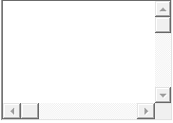

Date of the first payment:*



Number of Employees:*

Will the company hire subcontractors / subcontactors in the construction sector? *

Yes

No

Forename and Surname of the owner of the company :*



NIN of the owner of the company:*



Additional Information:

